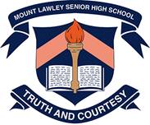

**Year 7 Chemical Science**

**Mixtures Test 2022**

**Section 1: Multiple Choice Questions (25 marks)**

Read all answers and choose the **BEST** one. **(1 mark each)**

1. 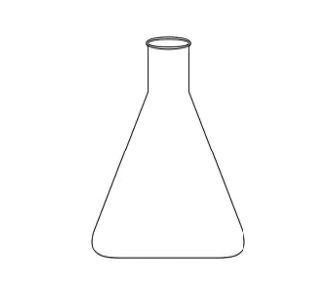The name of this piece of science equipment is a:

a) Conical flask

b) Test tube

c) Gauze mat

d) Tripod

1. Solutions are made up of two parts called the:

a) Solution and solute

b) Solute and solvent

c) Solution and solvent

d) Solution and suspension

1. The terms Solubility refers to:

a) The type of mixture formed  
b) A substance that cannot dissolve  
c) The ability of a substance to dissolve in a liquid  
d) A type of mixture in which a suspension forms

1. A mixture is a combination of two or more:
   1. Substances
   2. Atoms
   3. Elements
   4. Gases
2. The item of equipment that you would use to ‘measure a volume of water exactly’ is the:
3. Beaker
4. Measuring cylinder
5. Test-tube
6. Pipette
7. A mixture that contains undissolved particles that are dispersed (spread) evenly throughout the liquid is called what type of mixture:
8. Element
9. Solution
10. Suspension
11. Colloid

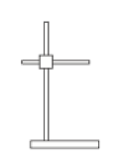

1. The item of equipment shown in the below diagram is:
   1. Tripod stand
   2. Retort stand
   3. Resin stand
   4. Evaporating stand
2. If a substance does not dissolve, it is called:
3. Saturated
4. Soluble
5. Saline
6. Insoluble
7. In a solution, the substance that dissolves is the:
8. Solvent
9. Solute
10. Suspension
11. Element
12. In a solution, the substance that does the dissolving is the:
    1. Solvent  
       b) Solute  
       c) Suspension  
       d) Element
13. A bottle of medicine has a sticker on it that tells you to ‘Shake well before using’. The mixture in the bottle is most likely a:
    1. Solution
    2. Compound
    3. Colloid
    4. Suspension
14. Which mixture does not scatter light to produce the Tyndall Effect?
    1. Colloids  
       b) Emulsions  
       c) Solutions  
       d) Suspensions
15. A glass with a large amount of cordial in a small amount of water is said to be:
    1. Dilute
    2. Concentrated
    3. Strong
    4. Saturated
16. Which of these is a pure substance?
17. Bread
18. Milk
19. Distilled Water
20. Coffee
21. A solution where so much solute has been added to the solvent so that no more can dissolve is:
22. Dilute
23. Strong
24. Saturated
25. Weak
26. Which of the lists below shows mixtures in which the particles dispersed in the liquid are increasing in size?
    1. suspension, colloid, solution
    2. colloid, solution, suspension
    3. solution, colloid, suspension
    4. solution, suspension, colloid
27. Which of the following would not be described as a colloid?
    1. Saltwater
    2. Fog
    3. Foam
    4. Smoke
28. Which of these is not an Impure substance?
    1. Emulsions
    2. Mixtures
    3. Compounds
    4. Colloids
29. Which item of equipment would you use to hold a test-tube that is being heated:
    1. Tongs
    2. Gauze mat
    3. Test-tube rack
    4. Test-tube holder

1. The yellow flame of the Bunsen burner is called the:

a) Heating flame

b) Open air-hole flame

c) Boiling flame

d) Safety flame

1. Which of these mixture types would have visible particles that could settle to the bottom of the mixture?
2. Solution
3. Suspension
4. Colloid
5. Element
6. If a blue powder was stirred into a beaker of water, how would you know that the powder has dissolved in the water?
7. The powder would settle to the bottom of the beaker and leave the water clear.
8. The powder would settle to the bottom of the beaker, leaving the water cloudy and coloured.
9. The powder would disappear, leaving the water clear and coloured.
10. The powder would disappear, leaving the water cloudy.

The next 3 questions relate to the information in this table:

|  |  |  |  |
| --- | --- | --- | --- |
| **Test Tube No.** | **Solvent** | **Solute** | **Observation** |
| 1 | Water | Salt | Soluble |
| 2 | Water | Cooling oil | Insoluble |
| 3 | Kerosene | Water | Insoluble |
| 4 | Kerosene | Salt | Insoluble |
| 5 | Kerosene | Cooking oil | Soluble |
| 6 | Turpentine | Water | Insoluble |
| 7 | Turpentine | Salt | Insoluble |
| 8 | Turpentine | Cooking oil |  |
| 9 | Methylated spirits | Water | Soluble |
| 10 | Ethanol | water | Soluble |

1. Which of the following PAIRS of solvents are able to dissolve water?
2. Kerosene and methylated spirits.
3. Methylated spirits and turpentine.
4. Methylated spirits and ethanol.
5. Ethanol and turpentine.
6. Which of the solvents listed in the table is kerosene most similar to?
7. Water.
8. Turpentine.
9. Methylated spirits.
10. Ethanol.
11. From the information given, is cooking oil likely to be soluble or insoluble in turpentine?
12. Soluble.
13. Insoluble
14. There is insufficient evidence given.
15. None of the above.

**END OF MULTIPLE CHOICE SECTION**

**PLEASE MOVE ON TO SHORT ANSWER SECTION**



Name: __________________

**Year 7 Chemical Science**

**Mixtures Test 2022**

**Section 2: Short Answer Questions (30 marks)**

**Complete the following short answers questions**

1. 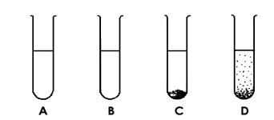Four substances called A, B, C and D were placed in water and shaken. The below diagrams illustrate what occurred when the mixtures were left for 5 minutes.

The four substances were then placed in alcohol and shaken. The below diagrams illustrate what occurred when the mixtures were left for 5 minutes.

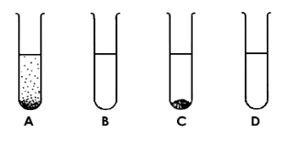

Use this information complete the below questions:

a). State the Solvent in: (1 mark)

Water

Alcohol

The first Diagram: _________________ The second Diagram: __________________

b). Complete the table below by writing **Yes** or **No** in each box: (4 marks)

|  |  |  |
| --- | --- | --- |
| **Substance** | **Is it soluble in water?** | **Is it soluble in alcohol?** |
| **A** | Yes | No |
| **B** | Yes | Yes |
| **C** | No | No |
| **D** | No | Yes |

c). Substance C is most likely what type of mixture when mixed with water? (1 mark)

Suspension

____________________________________________________________________________

1. Match the following scientists with their work by putting the correct number in the boxes:  
    (3 marks)

|  |  |  |  |
| --- | --- | --- | --- |
| **Scientist** | **Number** |  | **Work** |
| Physicist | **3** |  | 1. Investigates how rocks and mountains form |
| Chemist | **4** |  | 2. Studies living things |
| Biologist | **2** |  | 3. Explains things like movement, heat and light |
| Astronomer | **5** |  | 4. Studies how substances react with others |
| Geologist | **1** |  | 5. Studies space, stars, planets |
| Ecologist | **6** |  | 6. Studies how living things affect each other |

1. List 3 safety rules when working in a Science lab: (3 marks)
   1. Any 3 sensible rules that you have taught.
   2. _______________________________________________________________________________________________________________________________________________________________________________________
   3. _______________________________________________________________________________________________________________________________________________________________________________________
   4. _______________________________________________________________________________________________________________________________________________________________________________________
   5. A student uses a Bunsen burner to heat water in a beaker. Draw a scientific diagram to show the equipment set up. (4 marks)

Use ruler & pencil – Deduct ½ mark for not using ruler & pencil

Labelling – Deduct ½ mark for not labelling

½ mark each for all of these drawn:

Heatproof mat

Bunsen burner

Tripod

Gauze mat

Beaker

Water in beaker

1. Label the following parts of the Bunsen burner: (4 marks)

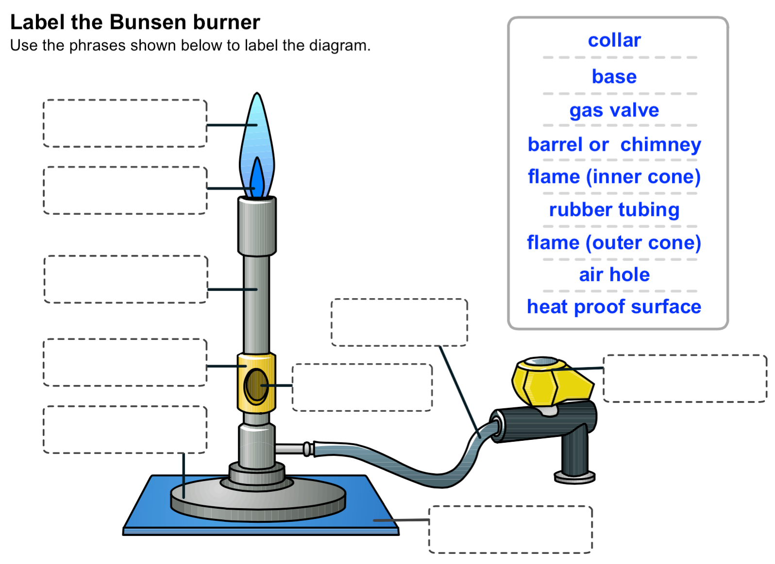

Gas Valve

Heat proof surface

Rubber tubing

Air hole

Barrel / Chimney

Flame (inner cone)

Flame (outer cone)

collar

base

1. Answer the following questions on the Bunsen burner:

a) Explain how to increase the amount of oxygen available to a yellow flame? (1 mark)

Student explains the air hole is adjusted to open to allow more oxygen

……………………………………………………………………………………………………....................

………………………………………………………………………………………………………………......

b) Explain the effect on the flame would this have? (1 mark)

The flame would turn from yellow to blue ( ½ mark) AND the flame would be hotter.( ½ mark)

…………………………………………………………………………………………………………………..

………………………………………………………………………………………………………………......

c) Explain why a yellow flame is called a safety flame when it is still hot enough to burn you:   
 (1 mark)

It is called a safety flame as it is more visible than the blue flame.

…………………………………………………………………………………………………………………..

…………………………………………………………………………………………………………………..

d).Explain why the gas must be turned on after the match is lit? (1 mark)

The gas must be turned on after the match is lit to prevent gas building up in the atmosphere surrounding the Bunsen burner and possibly causing an explosion.

………………………………………………………………………………………………………………......

………………………………………………………………………………………………………………......

………………………………………………………………………………………………………………..…

1. A woman spills ink on her dress. The dress is made from nylon.

Look at this table:

a) Which liquid should she use to remove  
 the ink stain? ___________________  
 (1 mark)

C

b) Explain your answer: (1 mark)

The liquid needs not to dissolve nylon but be able to dissolve the ink.

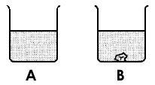

1. You are given two different salt solutions:

You put a crystal of salt into each solution. The crystal in beaker A has disappeared, and

the crystal in beaker B has become bigger.

Explain the result in Beaker A: (2 marks)

The salt solution is not saturated (1 mark) and is therefore able to continue to dissolve salt into the solution (1 mark). Or anything similar.

Explain the result in Beaker B: (2 marks)

The salt solution is saturated (1 mark) and is therefore cannot dissolve salt into the solution and salt crystal has become larger due the the saturation (1 mark). Or anything similar.

**END OF TEST**

Multiple Choice / 25

Short Answer / 30 TOTAL / 55